How this works?

1. RPA process written using tool – Softomotive Process Robot.
2. Please refer workflow diagram.

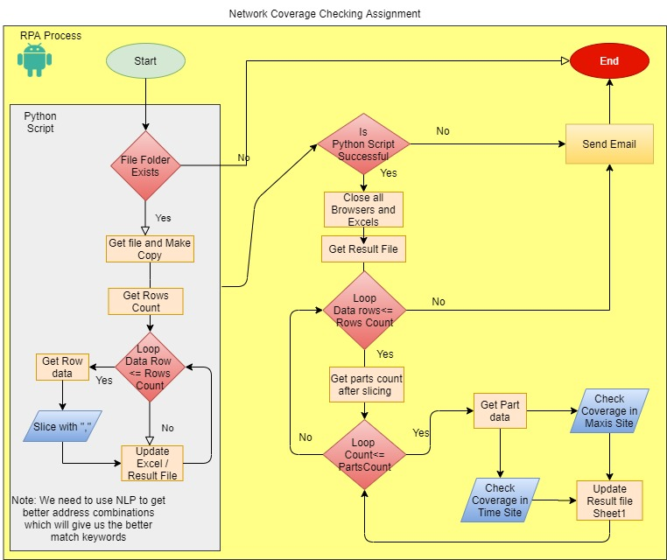

1. RPA Process triggers python script using command line editor
2. Written python script to slice the address data -It reads excel file from a folder

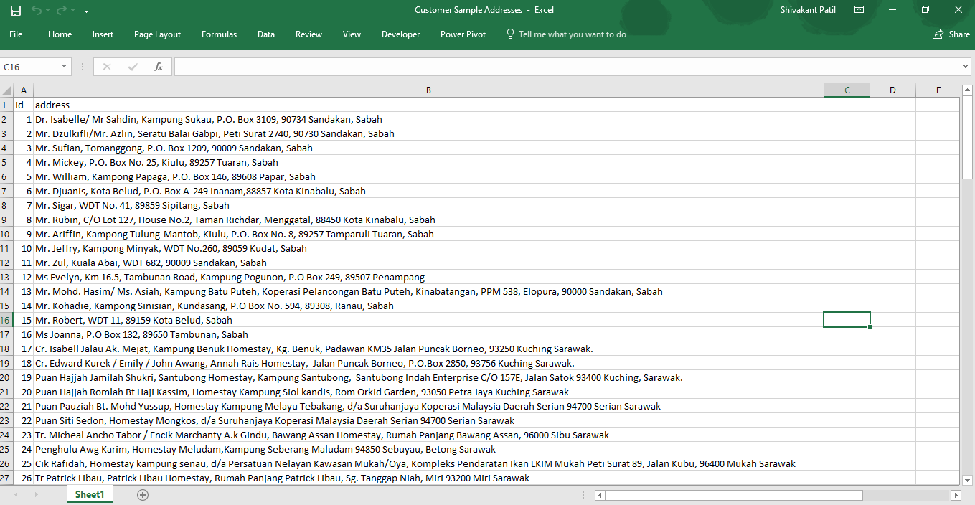

1. Make excel copy as Result file
2. Picks data from sheet1 & Slices address data by ‘,’
3. After slicing, data gets stores in the sheet2 as below.

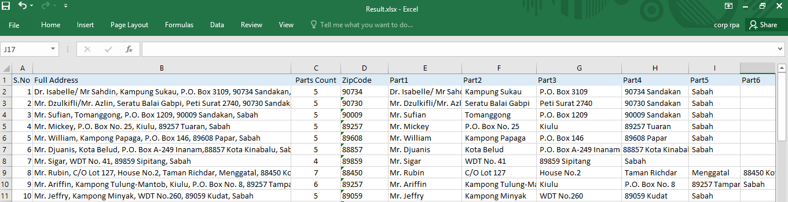

1. Triggers power shell commands to close all browsers and all excel files opened to make a fresh start.
2. On successful run of python script, output file result.xlsx file is read by rpa tool. Otherwise process sends error report and ends here.
3. Reads 1st address, reads parts count and fetches parts and searches in Maxis site.
4. Updates status on Sheet1 Maxis column as below.

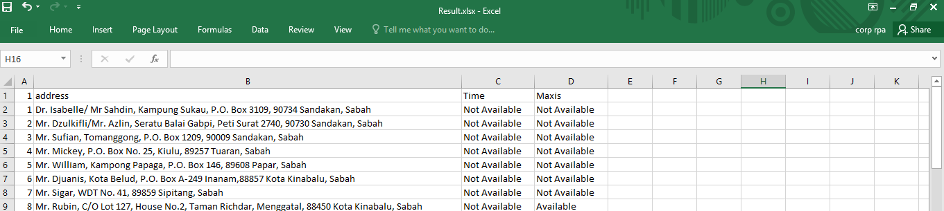

1. Searches Same in Time site and updates status in Sheet1 Time column.

Note:

1. Here while searching script is looking for some specific output like ex: Maxis fiber not available in your area in maxis site and We’re Sorry isn’t within coverage in Time site. Based on this result sheet getting updated as available / not available.
2. Result accuracy is depending on the accuracy of the address input keywords/ format passed as search text.
3. Ideally, we need to use NLP to get right address keywords and make standard address format depends on the site search criteria.
4. This goes till last record.
5. On completion Sends email along with attachment and process ends.

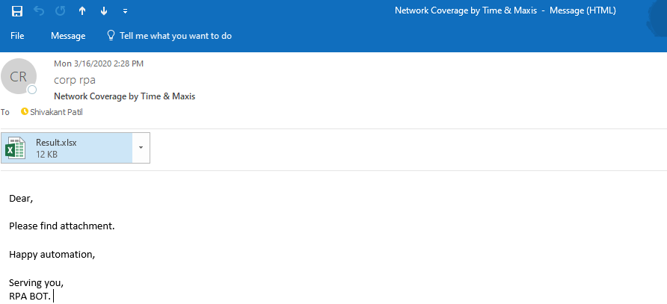

1. Please run video to watch the demo.

Note:

1. To complete all the address, process taking long time. To show complete run, I have kept only 2 addresses in the input file.
2. Used breakpoints & message display activities to make video more interactive.